**DAILY ONLINE ACTIVITIES SUMMARY**

|  |  |  |  |  |  |  |  |  |
| --- | --- | --- | --- | --- | --- | --- | --- | --- |
| **Date:** | **21-5-2020** | | | | | **Name:** | **Prajna** | |
| **Sem & Sec** | **8th sem ‘B’** | | | | | **USN:** | **4AL16CS067** | |
| **Online Test Summary** | | | | | | | | |
| **Subject** | | **SMS** | | | | | | |
| **Max. Marks** | | **60** | | **Score** | | | **27** | |
| **Certification Course Summary** | | | | | | | | |
| **Course** | **Getting started: Hadoop** | | | | | | | |
| **Certificate Provider** | | | **Great Learning** | | **Duration** | | | **33min** |
| **Coding Challenges** | | | | | | | | |
| **Problem Statement:**1**.** Write a python program to right rotate an array to k number of steps. | | | | | | | | |
| **Status: Completed** | | | | | | | | |
| **Uploaded the report in GitHub**  **GitHub link:** | | | | | **Yes**  **https://github.com/alvas-education-foundation/prajna_k** | | | |
| **If yes Repository name** | | | | | **prajna_k** | | | |
| **Uploaded the report in slack** | | | | | **yes** | | | |

Online Test Details: (Attach the snapshot and briefly write the report for the same)

Certification Course Details: (Attach the snapshot and briefly write the report for the same)

Coding Challenges Details: (Attach the snapshot and briefly write the report for the same)

1)online test

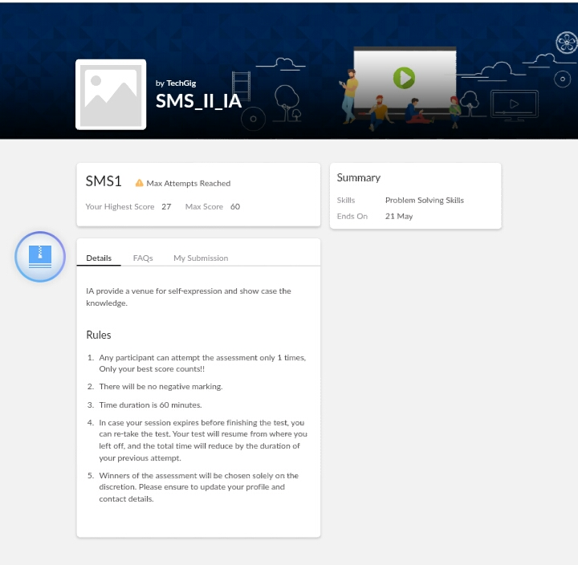

2) certification course

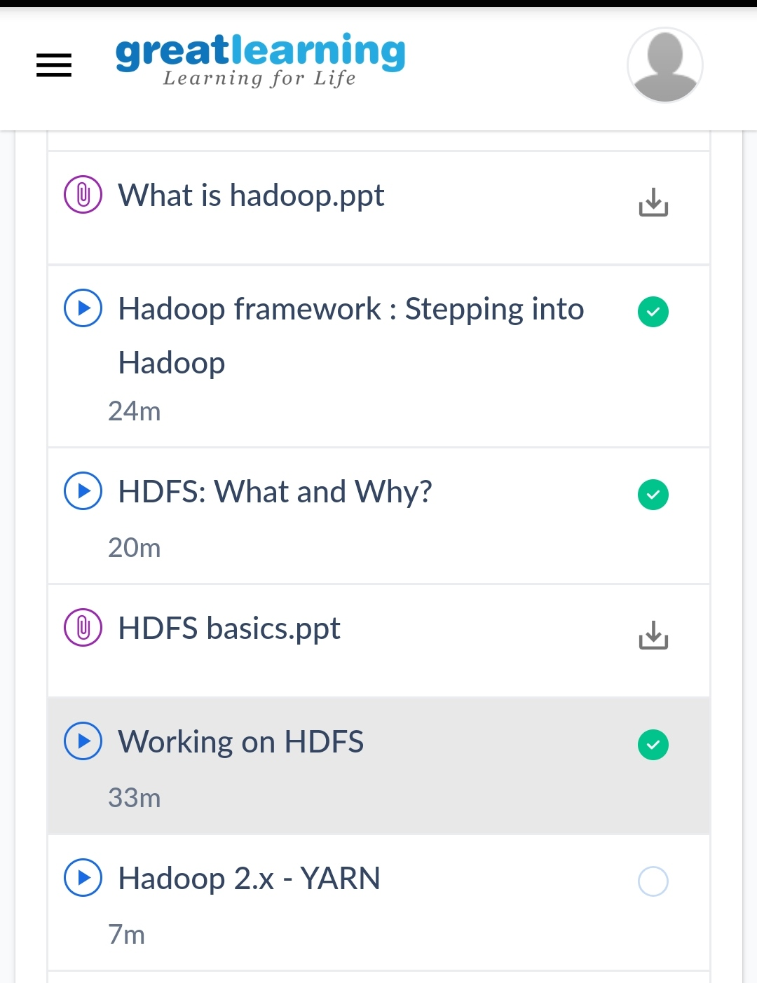

3) coding challenges

Program 1

|  |
| --- |
| #include <stdio.h>   // Function to right rotate an array by k positions  void rightRotate(int A[], int k, int n)  {     // construct an auxiliary array of size k and      // fill it with last k elements of the input array      int aux[k];      for (int i = 0; i < k; i++)        aux[i] = A[n-k+i];      for (int i = n-k-1; i >= 0; i--)          A[i+k] = A[i];      for (int i = 0; i < k; i++)          A[i] = aux[i];  }  int main(void)  {      int A[] = { 1, 2, 3, 4, 5, 6, 7 };      int k = 3;  int n = sizeof(A)/sizeof(A[0]);      rightRotate(A, k, n);       for (int i = 0; i < n; i++)       printf("%d ", A[i]);  return 0;  } |

|  |
| --- |
|  |
|  |  |
|  |  |
|  |  |
|  |  |
|  |  |